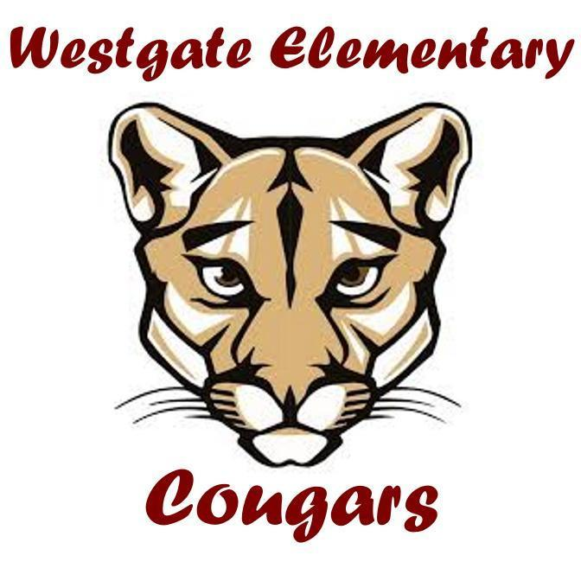
Westgate PSO General Meeting
January 18, 2023
Meeting called to order 6:32 pm - In attendance: 15 in-person, 3 on Zoom
Attendees:
- In-Person
  - Kristin Grecco, PSO Co-Chair
  - Ellen Sontra, PSO Co-Chair
  - Kalina Shouse, PSO Treasurer
  - Krysta Johnson, PSO Secretary
  - Kati Skeslien, PSO Fundraising Co-Chair
  - Amanda Rowland-Smith, PSO Enrichment Chair
  - Stephen Hearn, Westgate Principal
  - Dessie Petrova, Teacher
  - Cassie Sorge, Teacher
  - Kevin Fitzgerald
  - Brian Hartman
  - Maura Caley
  - Leah Winters
  - Kara Gillanders
  - Courtney Newhouse
- Zoom
  - Michele Hamilton, Office Manager
  - Ms. Whittman, Librarian
  - Liz Bennett
Agenda:
- Introductions (Kristin)
- Approve minutes from last meeting (Krysta)
- School happenings and updates (Mr. Hearn/Michele Hamilton)
- Treasurer update (Kalina)
- Yearbook
- Upcoming events
  - 2/23 - Science Night - More details to come + committee needed
  - April 24-28 Art Walk/Silent Auction Spring Fundraiser
- PSO Board Positions + Shadowing
- Questions/Comments (Open to all)
Minutes:
Meeting called to order at 6:32 pm
- Introductions (Kristin)
- Approve minutes from last meeting (Krysta)
  - Prior meeting minutes approved
- School happenings and updates (Mr. Hearnn)
  - Equity team is looking at the family survey that was filled out last spring to see how Westgate can be improved
  - This period of time, teachers know their children and it’s an exciting time
  - Third graders are very thankful for watercolors grant
  - Six grade teachers are starting to think about an end of the year celebration
  - Student council is planning the next spirit day - Monochrome day
  - Student council leaders (5th and 6th graders elected by their peers) presented at MLK assemblies and it went well
  - Teachers are curious about the format of the Art Walk with staffing concerns. If teachers have classrooms open from 6-7 pm and then we move everyone to the gym, will that work?
    - Since the silent auction is online, PSO planned to have tangible items on display somewhere but there would be no bidding on site at the Art Walk (all online)
    - 6-7 pm should work as a time frame - in previous years, it’s just been in the hallways, but teachers are looking for a more open house kind of feel
    - Can other families go into classrooms that aren’t their students to see the art?
      - Previously, this is why the art has been in the hallways
      - Teachers would need to know ahead of time to know what to put out on display in their classrooms
    - There are no formal plans of auction kid art this year
  - Staff is curious how they can support science night (to be discussed later in the meeting)
  - In the past, Westgate has had art docents and the building team is wanting that to happen. It has happened in the past, but was put on hold during covid. It would be great to start planning this for last year. Mrs. Engbert oversaw the program and is now at the Woodway Center. Would need to find someone to run it.
    - Parents volunteer to come into their kids classrooms that would take turns designing a project using school art supplies and have them set up for the parent to come in and design art with the students
    - There was a 1 hour training involved and some local art businesses provided support (ideas)
    - We would need someone at Westgate to oversee it, previously there had been submission/request forms
    - Intermediate grades have historically had less volunteers and some classes had no art docents - would be worth considering the pre-covid proposal so we can spread the volunteerism around.
    - Should consider reaching out to Cascadia Art Museum and Edmonds Arts Commission
    - PSO does have a $500 budget for art supplies (in addition to what the school has on hand) - this wasn’t heavily leveraged previously
    - Leah Winters is interested in working on it with a team and we would need a staff liaison - Leah to reach out to Mrs. Engbert to ask about logistics and budget
- Treasurer update (Kalina)
  - See separate report
  - Final invoice from Harvest Fest paid - the event paid for itself
  - Greenery sales were a success for the first year
  - Amazon Smile is ending their program next month, so we should have a final check coming from them
  - $3,000 was allocated for an assembly - PSO will present some ideas to the school
  - In the past, we’ve had a community member put on a theater production and have it budgeted. It is TBD if this event will occur this year.
  - Coming into this year, we had a deficit and we’re close to closing that gap with the fundraising done this year to date
- Yearbook
  - PSO is working with Dorian to put on the yearbook this year
  - They will be sold, not provided as they have been the last two years
    - Results were mixed from parents and it was made clear that school supplies are a bigger help and a better priority
  - Parents can donate money to buy additional yearbooks for students that want them
  - PSO to work with teachers to make sure that every student that wants a yearbook gets one
  - For all other students, PSO will provide a printable autograph book to teachers so that they can still connect and have something to have signed
    - PSO is also happy to have these printed and pay the cost
  - Yearbook prices have gone up and will be about $15
  - PSO is looking for a 6th grader to provide artwork, which is due January 27th
    - 6th grade teachers have not discussed this yet - if this is something the PSO would like to continue, it would be good to work it into the docent program or curriculum so it’s less of a competition or popularity contest
    - PSO will follow the lead of the 6th grade teachers, but also can use a stock cover
  - Dorian will come out and take group photos for the school and will handle the layout
  - PSO is hoping for a parent that is willing to take the lead on this to help coordinate what photos go in the yearbook and what photos teachers want included
  - In future years, the PSO will look into other options earlier and evaluate what company they go with in 23-24.
- Upcoming events
  - 2/23 - Science Night - More details to come + committee needed
    - 6 PM
    - We need help trying to find more presenters! Please email Amanda with any ideas.
    - Presenters get dinner provided by the PSO at 5 PM before the event
    - If teachers have ideas for presentations/topics, please share and PSO will own getting presenters
    - We will also need to know which teachers will let them use their rooms so we have a better understanding of space
    - Additional announcements will go to the room parents and will appear in the newsletter
    - Side note: Room parents don’t have emails for most parents - it would be helpful if we can get additional email addresses
      - Alternatively, PSO/room parents could send the emails/notifications to teachers so they can distribute via ParentSquare
      - For next year, it would be good for teachers to think about communications for next year - PSO wants to support and doesn’t want to ask too much of teachers!
  - April 24-28 Art Walk/Silent Auction Spring Fundraiser
    - Timing is still being finalized
    - Last year, the silent auction raised $6,000 in its first year
    - We are looking for additional donations - if you have ideas, please send to the PSO as we are tracking who has been asked to date
    - If families want to donate, please reach out to the PSO
    - Procurement deadline is April 1st, so we have time to set up the platform
- PSO Board Positions + Shadowing
  - Our board is full next year, but we are looking for shadows for some positions next year
  - If anyone is interested in having a role on the board, please reach out to the PSO
  - PSO will also have Michele reach out to Woodway Center for incoming first grade parents
  - Even if people are not interested in board positions, there are many opportunities to join a committee or volunteer opportunities
- Questions/Comments (Open to all)
  - None

Meeting called to a close at 7:32 PM

